Assignment – 9

- Get employees who have the highest salary

select * from Employee where Salary in (select max(salary) from Employee) limit 1;
select * from Employee where Salary in (select max(salary) from Employee);
select max(salary) from Employee;


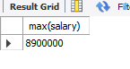
- Get employees who have the 2nd highest salary--

select * from Employee order by salary desc limit 1,1;
select Employee_id, max(salary) from Employee where salary <> (select max(salary)from Employee);

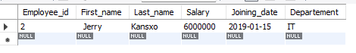
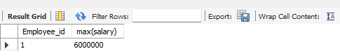
- Get employees who have the nth highest salary

select * from Employee order by salary desc limit 3,1;
select * from Employee e1 where 4 = (select count(distinct e2.salary) from Employee e2
where e1.salary <= e2.salary);

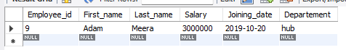

- Categorize employees into three groups based on their salaries (less than 30M-low,30M to 60M-medium, greater than 60M-high)

select Employee_id, First_name, Salary,
case
when Salary <3000000 then 'low'
when Salary >= 3000000 and 6000000 then 'medium'
else 'high'
end as catagorized_salary from Employee;

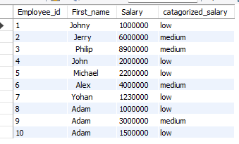
4. Explain the 3 rd question with detailed breakdown

select * from Employee e1 where 4 = (select count(distinct e2.salary) from Employee e2
where e1.salary <= e2.salary);

- select * from Employee;

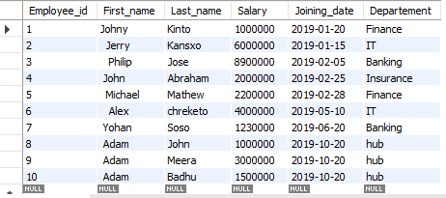
- select count(distinct e2.salary) from Employee e2;
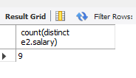
Note: Employee_id 1 and 8 have same salary

- select count(distinct e2.salary) from Employee e2 inner join Employee e1
where e1.salary <= e2.salary;

here count of distinct salary from e2 is taken and is compared with all the data from Salary from e1 . The list is seen but it is ordered in desc based on the <=

same count is given as 9

- select * from Employee e1 where 4 = (select count(distinct e2.salary) from Employee e2
where e1.salary <= e2.salary);

here after it took the 9 values which are distinct it gives us the fourth value (salary) from the Employee table in the desc order.

Note: select * from Employee e1 where 4 = (select count(distinct e2.salary) from Employee e2 where e1.salary >= e2.salary;
in this the fourth from bottom is given

